**1. What is the size of MBR and what does it contains.**

**Ans:** 512 Bytes (446 Bytes Bootloader+64 Bytes Partition table+2 Bytes Magic Number which is AA55H)

**2. In which file you can write commands which you want to run whenever Linux system starts/restarts?**

**Ans:** /etc/rc.local

**3. Reboot the system using runlevel.**

**Ans:** init 6

**4. Restart cron service.**

**Ans:** sudo service cron restart

**5. Create an ext4 filesystem**

**Ans:** mkfs.ext4 /dev/sdb1

**6. Mount the created filesystem on /partition directory.**

**Ans:** mount /dev/sdb2 /home/usb

**7. Create a LVM**

pvcreate /dev/sda6 /dev/sda7

vgcreate vol_grp1 /dev/sda6 /dev/sda7

lvcreate -l 20 -n logical_vol1 vol_grp1

**8. Create RAID1**

* **Create partitions** on these two drives using ‘fdisk‘ command say /dev/sdb and /dev/sdc
* **Verify the changes** on both sdb & sdc  
  #mdadm -E /dev/sd[b-c]
* **Create RAID1 Device** called ‘/dev/md0‘  
  #mdadm --create /dev/md0 --level=mirror --raid-devices=2 /dev/sd[b-c]1  
  #cat /proc/mdstat
* **Check the raid devices type**:  
  #mdadm -E /dev/sd[b-c]1  
  #mdadm --detail /dev/md0
* **Create file system** using ext4 for md0 and mount under /mnt/raid1  
  #mkfs.ext4 /dev/md0  
  #mkdir /mnt/raid1  
  #mount /dev/md0 /mnt/raid1/

**10. Set setuid and setgid on two different file**

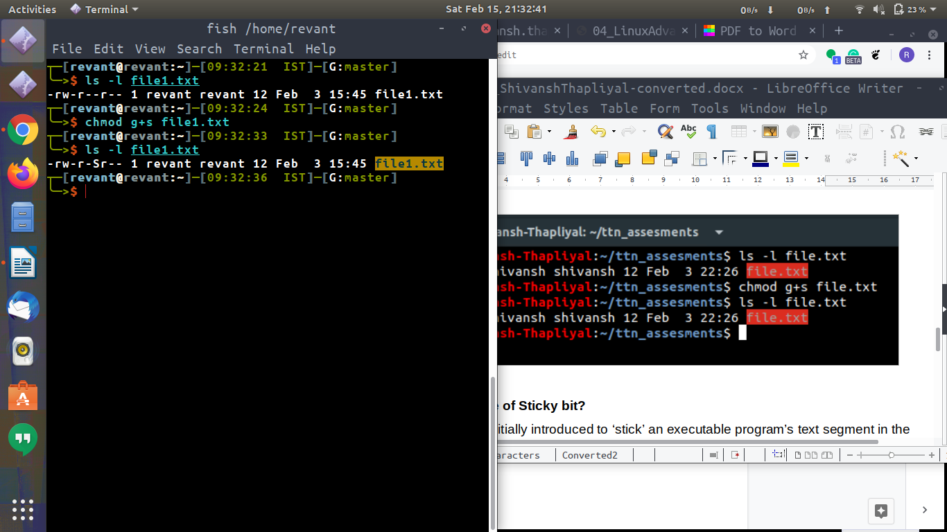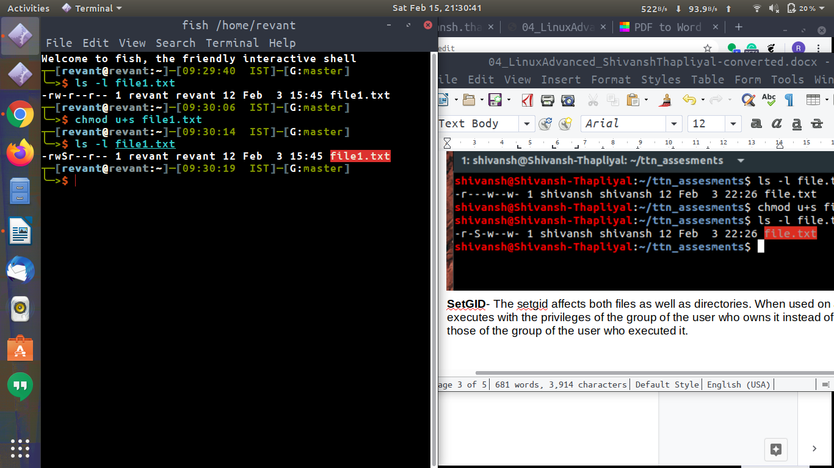

**11. Create a user and add it to one secondary group.**

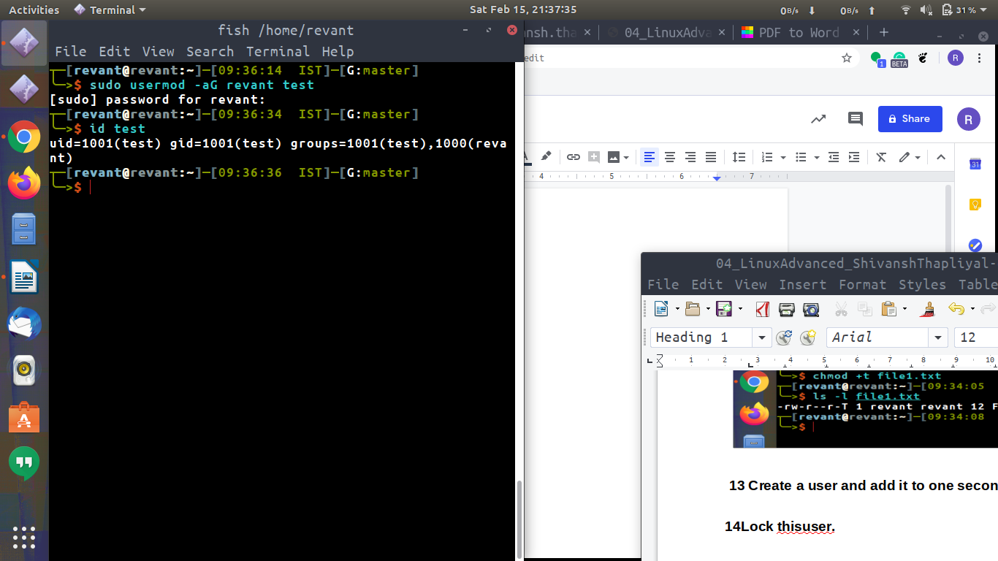

**12. Lock this user.**

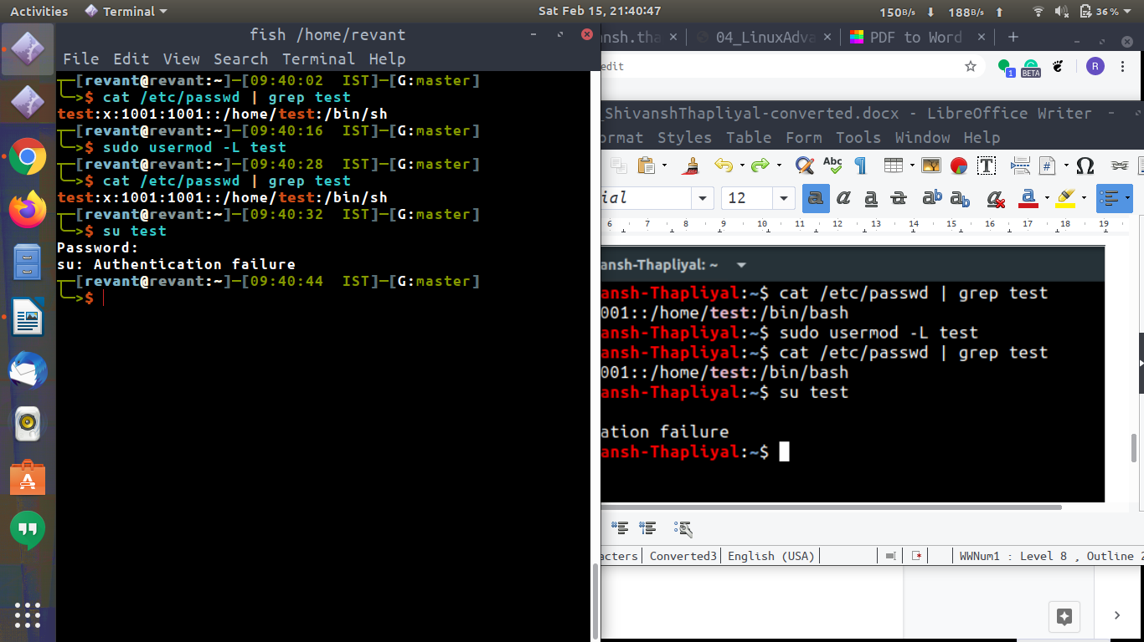

**13. Give this user full access (without password).**

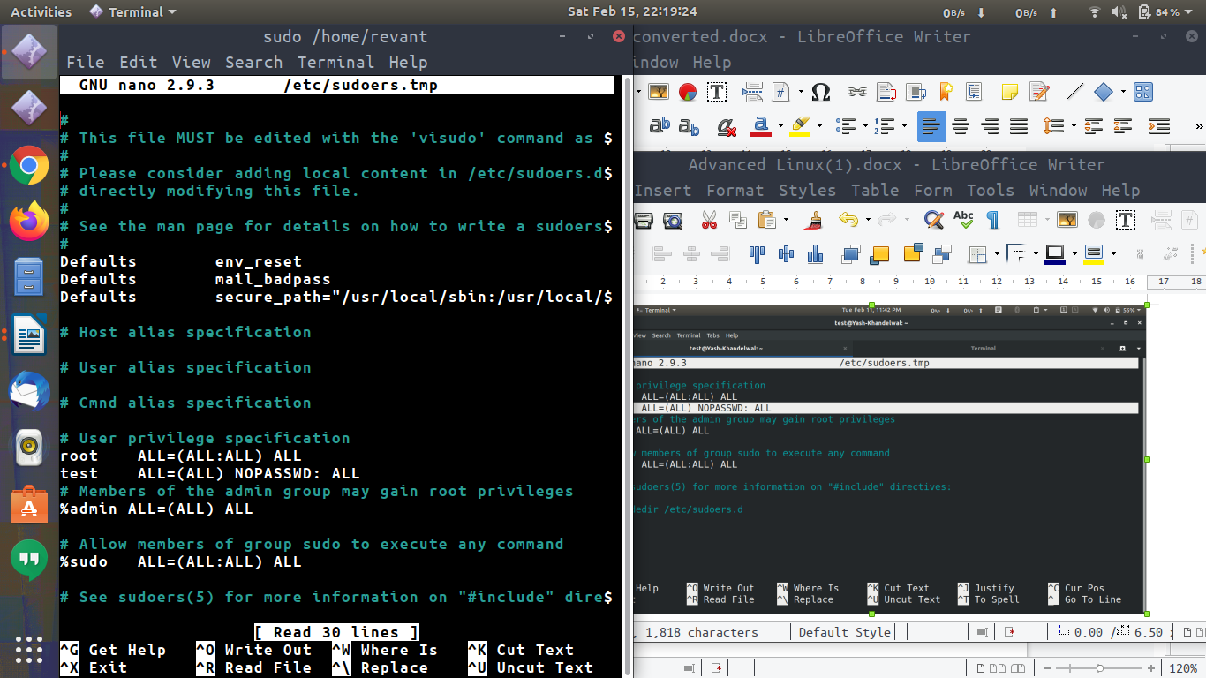

**Delete the create user after taking backup of it home directory.**

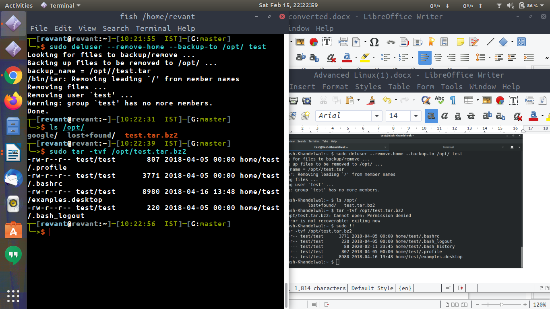

**15. Create a file with some content. Change all lower case letter to upper case letter and save output to another file**

**using redirections.**

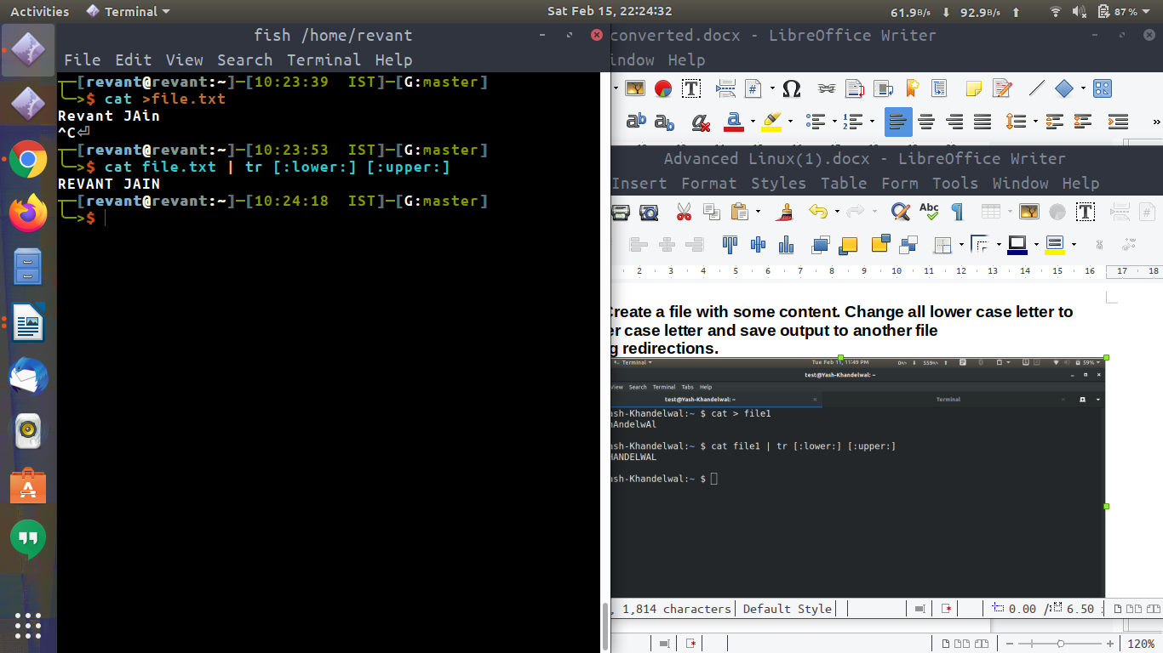

**16. Set nice value of a process to -1.**

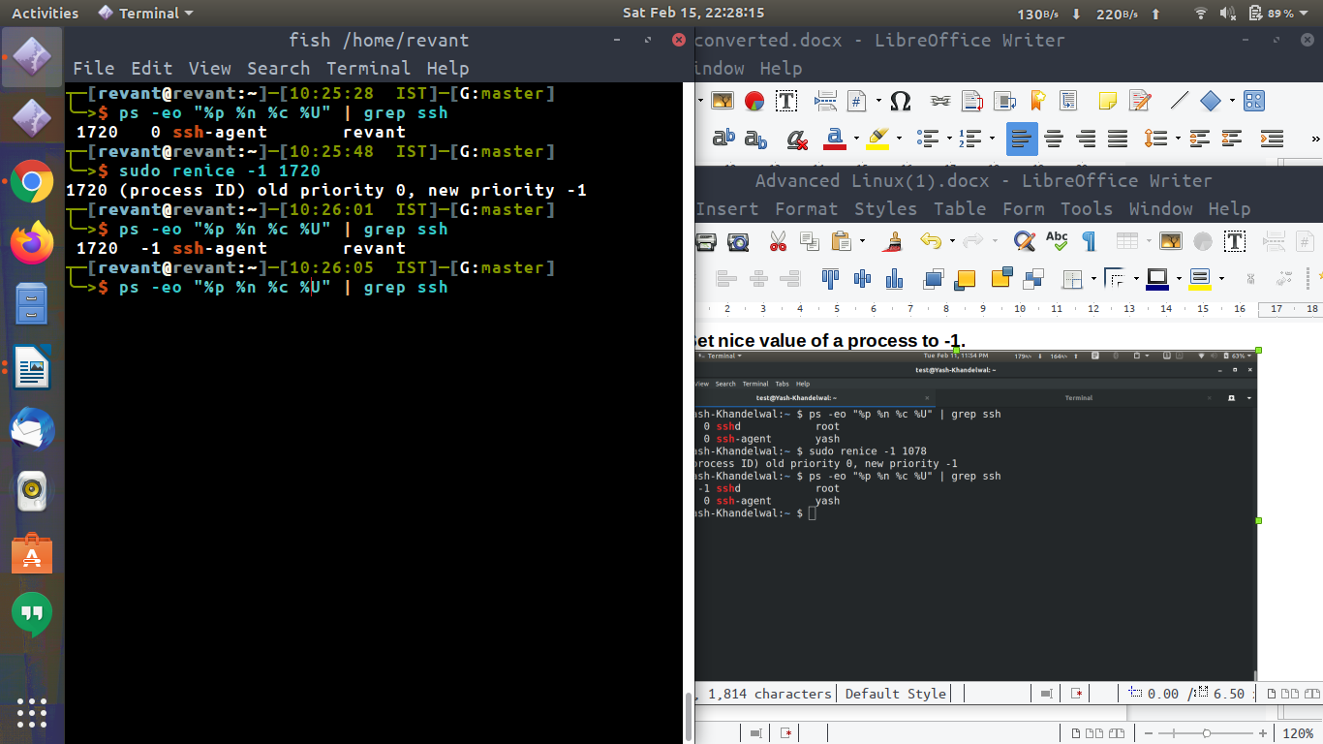

**17. Get list of all files used by “telnet”.**

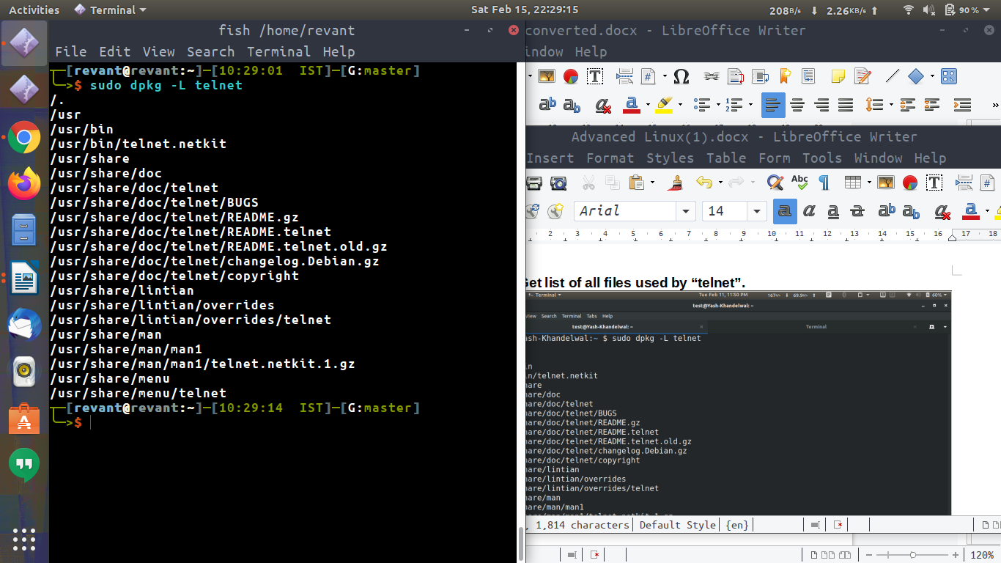

**18. Check if port 22 is listening using netstat and telnet command.**

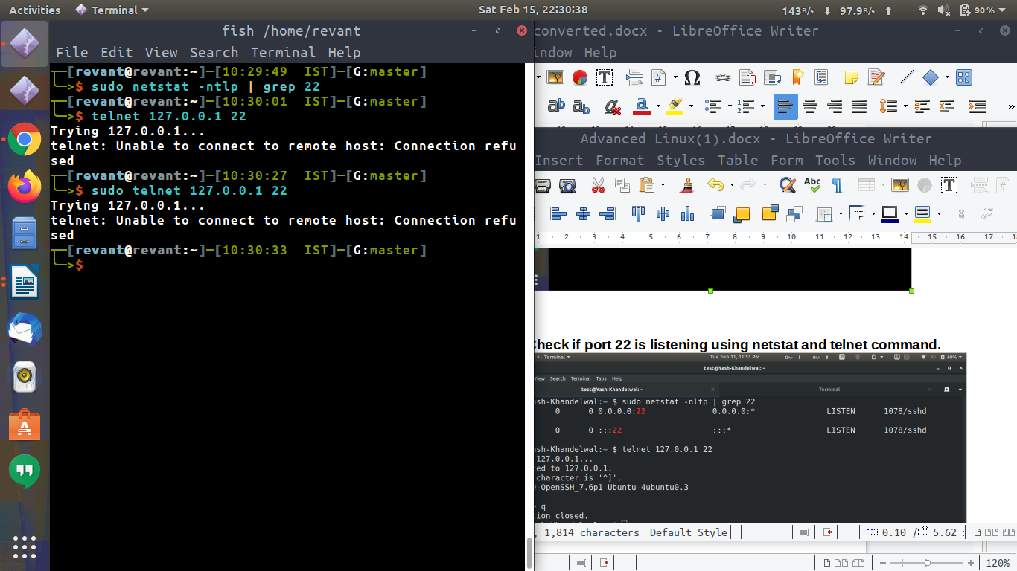

**19. Create a cron job which runs once in a week at 23:45.**

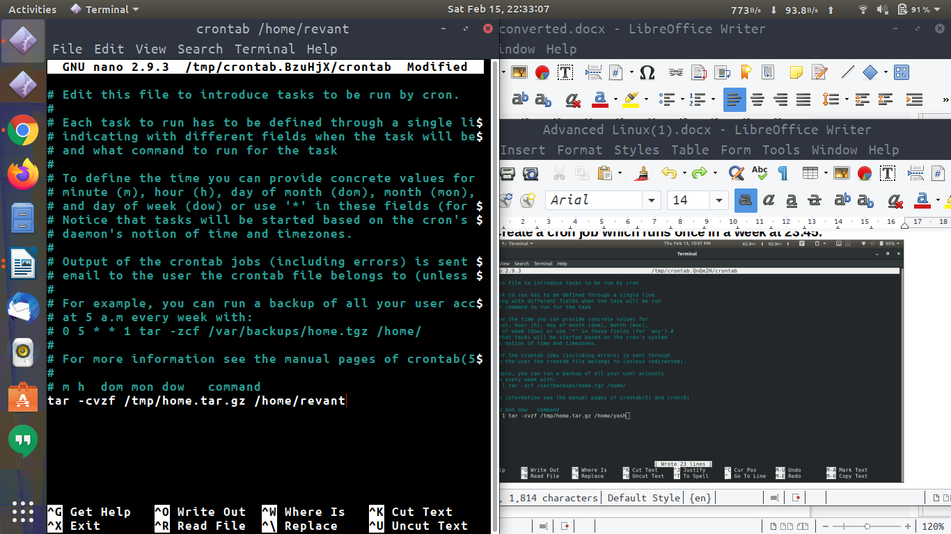

**20. Difference between dig and traceroute**

**Ans:** traceroute provide hops info and dig is DNS utility

